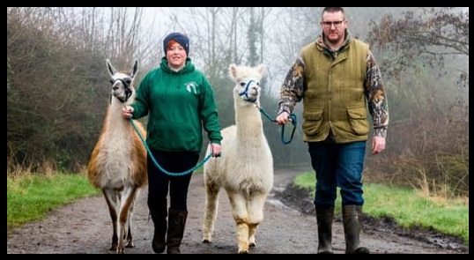
Joe’s Alpaca & Llama Walks
North Yorkshire

Risk
Assessment
Form v1.1

Activity: Alpaca and llama walks | Site: Hall Farm, Aislaby, Pickering, North Yorkshire, YO18 8PE
People at Risk: Visitors/customers  Animals at Risk: Alpacas and llamas | Additional Information:
Name of person completing form: Mr Joe Hodgson Job Title: Owner Date: 18/11/2024 |  | Review Date:18/11/2025
Hazard | Risk | How might it happen? | Initial Rating  L, M, H | Control Measures | Final Rating  L, M, H
Natural hazards such as mud/slippery surfaces/loose stones/unexpected mounds and depressions | Slip/fall/trip/  loss of footing | Failure to read or follow instructions.  Not wearing appropriate footwear.  Failure to take notice of where feet are being placed. | M  M  M | Notes accompanying booking confirmation.  Visitors are requested in advance to wear suitable clothing such as wellington boots, walking boots, etc.  A health and safety briefing is given at the start of each walk, walks are supervised by the owner. | M  L  L
Feeding the alpacas and llamas | Bites or infection | Visitors offering food to the alpacas or llamas. | L | Visitors can feed the alpacas and llamas after each walk with feed provided by the owner, the feed is contained in feed scoops for each animal and fed separately. | L
Touching/grooming | Bites or kicks | Visitor inappropriately greets alpaca or llama. | M | Visitors are told how alpacas and llamas behave and how to approach them in the safety briefing.  Visitors are shown where they can touch the alpacas and llamas and where NOT to touch in the briefing.  Children must be always supervised. | M
Leading | Alpacas and llamas may jump or otherwise panic and pull free of lead being held. | Alpacas and llamas can spook by sudden movements, appearance of dog, cyclist, etc. | H | All alpacas and llamas have been trained to be led and have been exposed to other animals and the routes taken for walks.  Visitors are well briefed on how to react and hand over control to owner.  Young children (i.e. under 10) are only allowed to lead an alpaca with an adult (two leads provided).  Children (i.e. over 10) if capable can lead an alpaca on their own.  Llamas can only be walked by adults. | M

Part of Joe’s Owl Encounters & Exotic Mobile Zoo
www.joesowlencounters.com

